- Welcome everyone, Im glad you were all able to make it out here today! My name is Laine Paglia and I am the program Administrator at Big Brothers Big sisters. I am also going to be the facilitator for this series called “Big Futures.”
- I would like to start off with a fun little ice breaker that we all can do and if you open up your yellow folders, you will see a white piece of paper paperclipped onto the pocket. What I would like everyone to do is create a name card, but then also draw something on your name card that represents something you are proud of that you have done in your life. Here’s mine for example, Im proud that I know how to cook, so I drew cooking utensils.
- I would like to go around the room, and lets introduce ourselves and what we drew on our card and why.
- Well its great to meet everyone and I’m glad you all made it out here safely. Really quick, I would like to go over the contents of the yellow folders so you all know what’s in them.
- So today we will be discussing how to develop confidence and going over some of the things we can do ourselves to help build confidence with in us.
- I have a video that I would like to show you to kind of get the ball rolling as we start.
https://www.youtube.com/watch?v=D9OOXCu5XMg
- Lets dive right in to what this series is going to be about and talk about how employers are always seeking people who will bring a positive attitude to the office. They want employees who will be friendly to others, eager to work, and generally a pleasure to be around. Being able to keep things positive is especially important if you’re working in a fast-paced, high-stress work environment.
- The first positive attributes that employers are looking for would be Confidence.
- But in order to have confidence, you have to know who you are as a person.
- “Who am I” is one of life’s greatest questions and so I would like to invite the Bigs to turn and have a short conversation with your little about how to understand and answer this question. Maybe answer it yourself first so that your Little knows how to answer it next.- 5 minutes
- Building confidence can be a little tricky, some people were born with confidence and for others, it might be harder to find the confidence to make something happen. So I have a little activity for you guys to do with your mentor. On a piece of paper, I want you to write down all of your achievements and your mentor can help and assist in that. Then, I want you to write down 3 goals that you and your mentor could accomplish together. It can be over the span a week, a month, or a year even if you’d like. – 10 minutes
- When we build up our confidence what we are doing essentially is taking a step out of our comfort zone enough times it becomes comfortable where before we weren’t. Here’s a diagram to help show that.
- 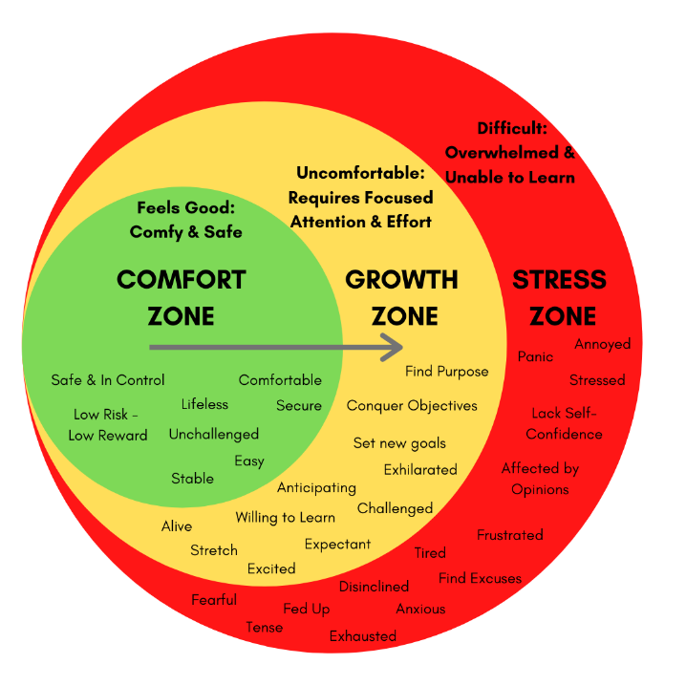
- Building confidence takes time, its not something that happens over night. I would like to invite our Bigs to share their experience in developing confidence throughout your life and how it has changed for you with your Little. – 10 Minutes
- Now Littles, after hearing what your Big just told you, talk to your Big about what you might be doing right now that is helping you grow and gain confidence. It could be something you are doing at school or outside of school. – 5 minutes
- To wrap everything up, as you can see, there are things we have already accomplished in our lives that we are proud of and things that we want to accomplish in the future to. I want to make sure that all of our mentors keep track of what your Little wrote down for what they want to accomplish with you and the hope is that you guys can make that happen!
- To finish this up, if you open your folders and on the left side behind the scrap paper, you will find the survey that I mentioned earlier. Please take your time filling them out but also feel free to grab a drink or a snack as you work on the survey. Once your done, please bring your survey over to Erin, and she has your gift cards all ready to go for you.

