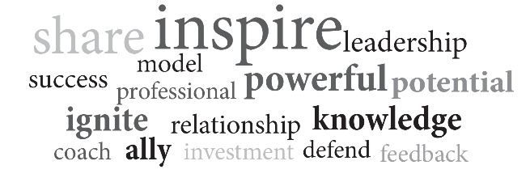
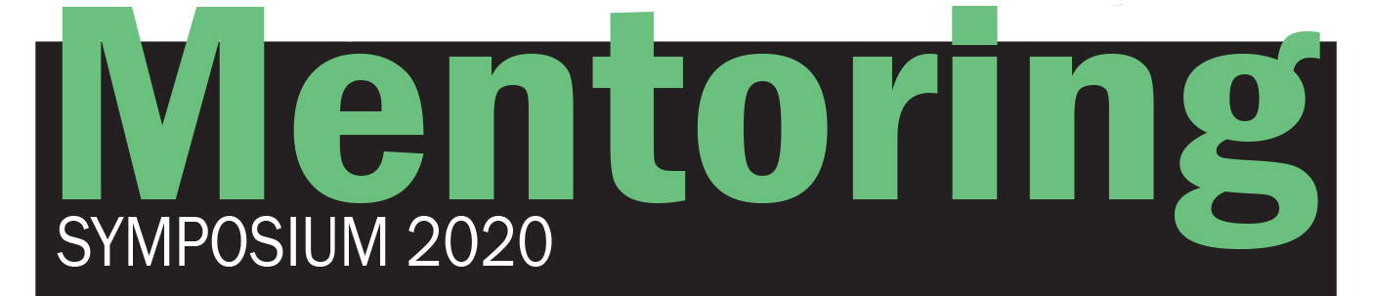
Request for Presenters
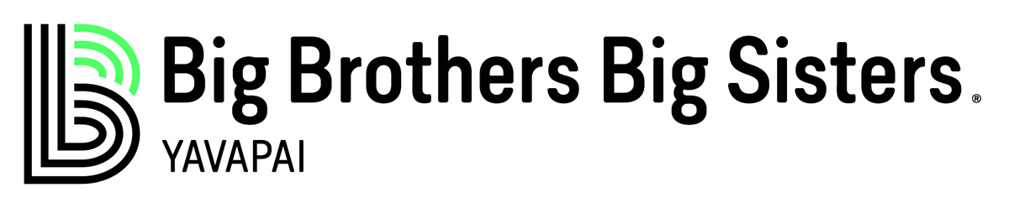
Power of Mentoring Symposium
January 10-11, 2020
Welcome Reception Jan. 10 & Presentations Jan. 11

We’d like to offer you the opportunity to share and connect at our Power of Mentoring Symposium. In addition to facilitating workshops, presenters are welcome to attend the conference free of charge. Presenters will receive a registration packet along with registration instructions in early October.

This symposium is geared toward those who seek professional support in these areas of mentoring: Education, health, safety, peer-to-peer, development, successful leadership, fostering, counseling, senior caregivers, nonprofits, government, faith-based and business.

This symposium is a unique opportunity to share your expertise and ideas with a highly-engaged audience of mentoring professionals, supporters and stakeholders. Sessions will cover best practices, evidence-based approaches and research.

(Workshops are 1 hour and 15 minutes in length. Please be prepared to fill the time slot.)

To apply to be a presenter, please complete the form below and e-mail to rlayton@azbigs.org or mail to 3208 Lakeside Village Drive, Prescott, AZ 86301
Application Deadline is August 31, 2019. SPACE IS LIMITED!

This conference is provided to you by the collaborative efforts of:
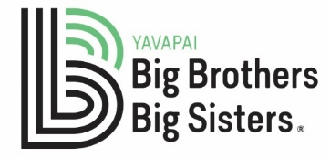

See topic areas, criteria for selection and application below:
Mentoring Symposium Application

Mentoring Tracks: Check the topics that best describe your presentation

- Youth education
- Youth advocacy
- Foster care
- Peer-to-peer mentoring
- Special education
- Counseling
- LGBTQ
- Juvenile justice
- Trauma informed
- Seniors
- Business
- Entrepreneurship
- Faith-based
- Nonprofits
- Government
- Self-care
- Caregiving

Presentation Title:
Presenter Name: Presenter Title:
Brief Bio of Presenter (3-5 Sentences):

Description of Presentation (3-5 Sentences to be included in Conference Registration materials):

Time Preference (check one) AM PM Willing to present twice? Yes No
Name: Agency:
Address: City: State: Zip:
Agency Telephone: Cell Phone:
E-mail:
Type of Presentation (Power Point, lecture, hands-on):

Audio/Visual Needs: Prescott Resort rooms are equipped with standard presentation technology.
Additional A/V Requirements: _________________________________________________________

Submit by email rlayton@azbigs.org or by fax 928-445-8909.
Criteria for Selection: Presenters will be notified by Sept. 1, 2019. Material must be informative in nature and not a marketing pitch.
Sessions should be designed to educate, showcase innovation, include Q&A periods and are not sales pitches. Presenters should be experienced in and committed to the topic.

Vendor Application
Thank you for your interest in a symposium vendor booth

Booth Type | Cost | What's included?
Single Booth | $200 | 2 Breakfast meals, 2 lunches, exhibitor badges for seminar access, 8 x 8 x 8' booth with 2 chairs and skirted table
Double Booth | $350 | 3 Breakfast meals, 3 lunches, exhibitor badges for seminar access, 8 x 16 x 8' booth with 3 chairs and 2 skirted tables
Special For Nonprofits (501c3)  Single  Double | $110  $210 | 2 Breakfast meals, 2 lunches, exhibitor badges for seminar access, 8 x 8 x 8' booth with 2 chairs and skirted table  3 Breakfast meals, 3 lunches, exhibitor badges for seminar access, 8 x 16 x 8' booth with 3 chairs and 2 skirted tables

To register your booth:

Name: Agency:
Address: City: State: Zip:
Agency Telephone: Cell Phone:
E-mail: Booth choice:

Seminar Tickets
Tickets go on sale Oct. 1 at azbigs.org or call (928) 778-5135 to reserve yours today!

Friday
$35 Reception with Keynote Speaker: Make-A-Wish Co-Founder Frank Shankwitz

Saturday Seminars
$155 general admission
$125 nonprofit members, seniors, teachers

Sponsor a Big to attend:
$75

